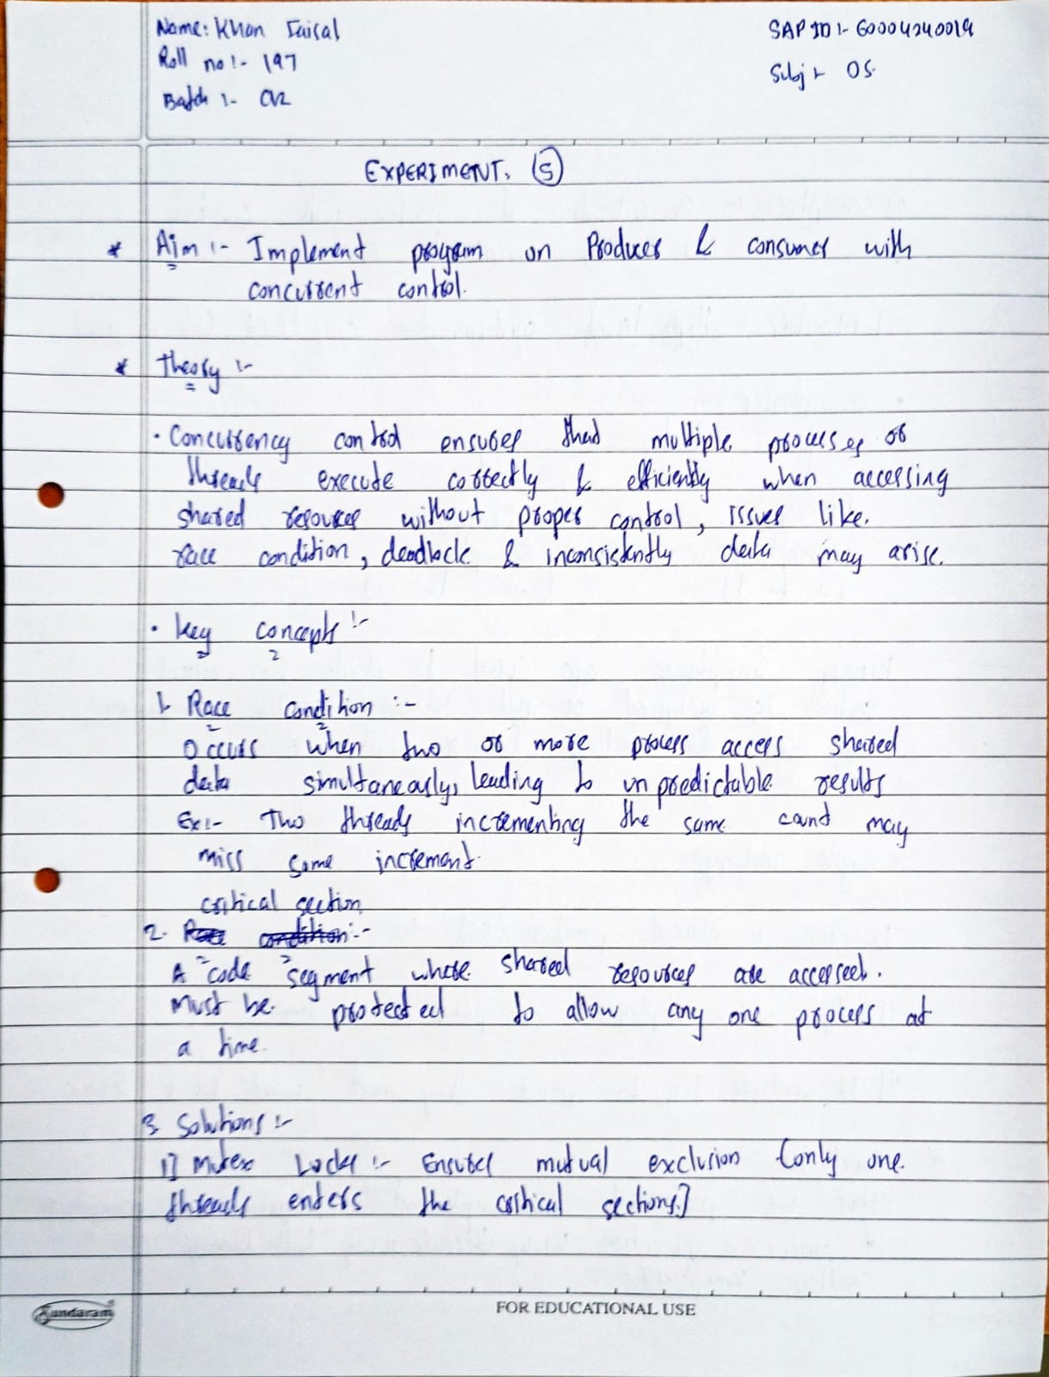

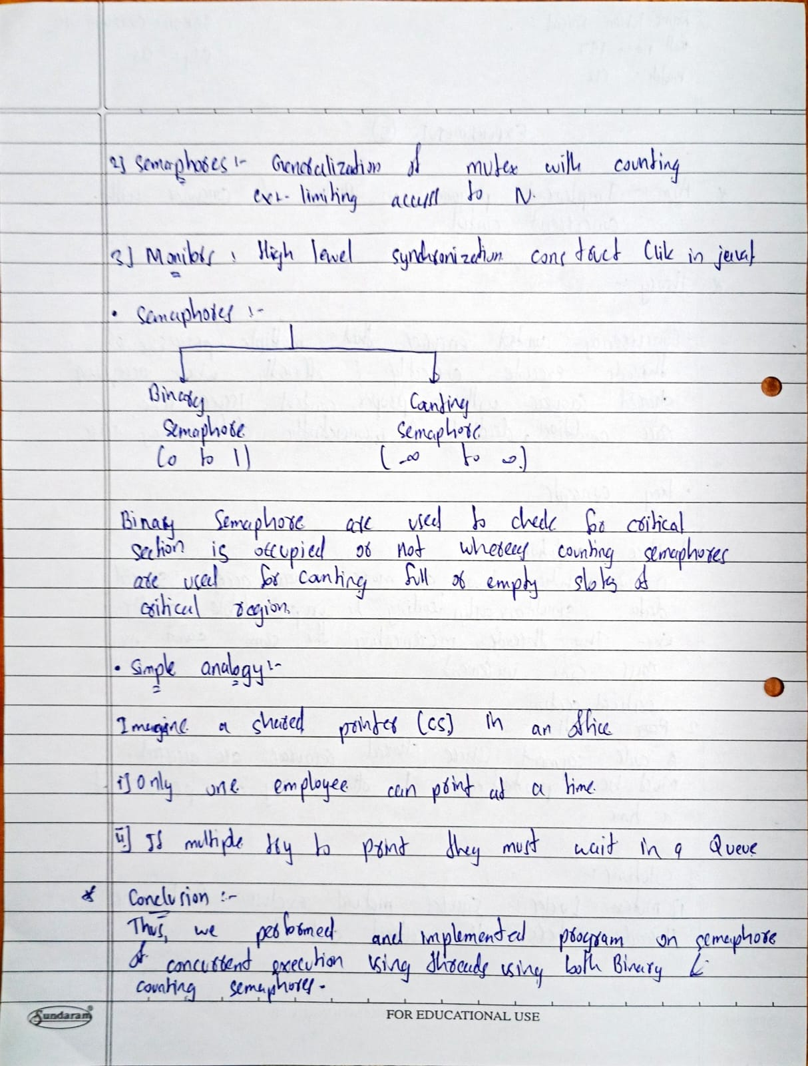

**Program (Concurrent Execution):**

#include <stdio.h>

#include <pthread.h>

#include <semaphore.h>

#include <unistd.h>

#define BUFFER_SIZE 5

#define MAX_ITEMS 20 // Total items to produce

int buffer[BUFFER_SIZE];

int count = 0;

int in = 0; // Producer index

int out = 0; // Consumer index

sem_t empty, full;

pthread_mutex_t mutex;

void* producer(void* arg) {

for (int i = 1; i <= MAX_ITEMS; i++) {

sem_wait(&empty); // Wait for empty slot

pthread_mutex_lock(&mutex);

// Produce item

buffer[in] = i;

in = (in + 1) % BUFFER_SIZE;

count++;

printf("Produced: %d\n", i);

pthread_mutex_unlock(&mutex);

sem_post(&full); // Signal new item available

sleep(1); // Simulate production time

}

return NULL;

}

void* consumer(void* arg) {

for (int i = 1; i <= MAX_ITEMS; i++) {

sem_wait(&full); // Wait for available item

pthread_mutex_lock(&mutex);

// Consume item

int item = buffer[out];

out = (out + 1) % BUFFER_SIZE;

count--;

printf("Consumed: %d\n", item);

pthread_mutex_unlock(&mutex);

sem_post(&empty); // Signal empty slot available

sleep(2); // Simulate consumption time (slower than production)

}

return NULL;

}

int main() {

pthread_t prod_thread, cons_thread;

// Initialize semaphores and mutex

sem_init(&empty, 0, BUFFER_SIZE);

sem_init(&full, 0, 0);

pthread_mutex_init(&mutex, NULL);

// Create threads

pthread_create(&prod_thread, NULL, producer, NULL);

pthread_create(&cons_thread, NULL, consumer, NULL);

// Wait for threads to finish

pthread_join(prod_thread, NULL);

pthread_join(cons_thread, NULL);

// Cleanup

sem_destroy(&empty);

sem_destroy(&full);

pthread_mutex_destroy(&mutex);

printf("Finished producing and consuming %d items\n", MAX_ITEMS);

return 0;

}

**Output:**

